

|  |  |  |  |  |  |  |
| --- | --- | --- | --- | --- | --- | --- |
|  | | | | | | |
|  | | BLACKBOARD | | |  | |
|  |  | | | | |  |
|  | | | ARYAN SRIVASTAVA (201210010) AARYA JHA (201210002) |  | | |
|  | | | CSB—Dr. SHELLY SACHDEVA |  | | |



|  |  |  |  |  |  |  |  |  |
| --- | --- | --- | --- | --- | --- | --- | --- | --- |
|  |  | | |  |  | | |  |
|  | ACKNOWLEDGEMENT | | | | | | |  |
|  |  | | |  |  | | |  |
|  |  | |  | | |  | |  |
|  |  |  | On this great occasion of accomplishment of our project on “BLACKBOARD”, we would like to sincerely express our gratitude to Dr. Shelly Sachdeva, who has been supportive through the completion of our project.  We would also be thankful to our Mr. Anil Kumar & Ms. Kanika Soni for providing all the required invaluable assistance in completion of this project.  This project has made us realise the potential we have as individuals and to put our theoretical knowledge into application. The exposure to reality has widened our extent of thinking.  We thank all our course coordinator, faculties and friends for providing all the required platform we required at stages of development of this project. | | |  |  |  |

|  |  |  |  |  |
| --- | --- | --- | --- | --- |
|  | | CONTENT |  | |
|  |  | | |  |
| **1** | **CASE STUDY** | | |  |
| **2** | **INTRODUCTION** | | |  |
| **3** | **SYSTEM REQUIREMENTS** | | |  |
| **4** | **ER DIAGRAM (PREVIOUS)** | | |  |
| **5** | **ER DIAGRAM (UPDATED)** | | |  |
| **6** | **MAPPING FROM ER TO R MODEL** | | |  |
| **7** | **RELATIONAL SCHEME** | | |  |
| **8** | **DATA DICTIONARY** | | |  |
| **9** | **SQL QUERIES** | | |  |
| **10** | **POPULATED TABLES** | | |  |
| **11** | **DATABASE CONNECTIVITY** | | |  |
| **12** | **FUNCTIONALITIES** | | |  |
| **13** | **BIBLIOGRAPHY** | | |  |

|  |  |  |  |  |  |  |
| --- | --- | --- | --- | --- | --- | --- |
|  | | CASE STUDY | | |  | |
|  | |  |  |  |  | |
|  | In the midst of the unforeseen pandemic, every single profession has suffered enormously due to the constraint being put forward in order to proceed further in respective fields. **Students have also been on the receiving end of this horrible situation. In order to overcome with the problems faced by students, “BLACKBOARD” will provide a platform for all students to organize their timetables, access all past year exam papers, a book barter system (intra-institution), social media (intra-institution) and add reminders.**  **Our aim is to create a portal which world combine and bring information and tasks related to the college on a single platform. This would substantially reduce time and effort, as the resources would no longer remain scattered across numerous websites and applications.** | | | | |  |

|  |  |  |
| --- | --- | --- |
|  | INTRODUCTION |  |

|  |  |  |  |
| --- | --- | --- | --- |
|  | **Blackboard is a student portal, which helps students stay organised with all their classes details, reminders, documents required for educational enlightenment and a book barter system. It provides a universal system for students which makes them enable to dwell onto their lives furthermore and explore themselves by being auto organised.**  **Over the graduation years, a student gets manifested with ample of assignments and to dos which is not always easy to recall in future, henceforth, we have created a reminder system, in which a student could personalize a reminder accordingly and which will be displayed on the dashboard.**  **In the midst of pandemic, the frustration of finding links for virtual classes can be a great hassle and sometimes could also lead to late arrival, in order to overcome this, we have also created a timetable of each branch year corresponding to the year which displays all the classes to be taken in the future along with designator course coordinator and class links.**  **The hassle of purchasing books every semester has also been addressed in this project of ours where a book barter system has been created for students to barter off their books over the semesters cutting down onto the costs of student.**  **Blackboard also contains a section for all the previous year question papers of mid and end semester examinations for students preparing.**  **Overall, Blackboard aims to be a mentor along with an auto organiser for students to aim higher than their potential by not wasting time on these minuscule but important bits and pieces of student lives.** | | |
|  | | SYSTEM REQUIREMENTS |  |

|  |  |  |  |
| --- | --- | --- | --- |
| SOFTWARE REQUIREMENTS | | |  |
|  | 1. HyperText Markup Language (HTML), Cascading Style Sheets (CSS), 2. Java Script (JS) for frontend Development[1] 3. MySQL for back-end query language[2] 4. Django (based on PYTHON 3.9.7) for scripting, and framework[3] 5. Chrome for Web Browser | | | |  |
|  |  | | | |  |
|  |  | | | |  |
|  |  | | | |  |
| **HARDWARE REQUIREMENTS** | | |  |
|  | 1. Operating system: | Windows7/8/8.1/10/11 | | |  |
|  | 1. Memory (RAM): | 1 GB or above | | |  |
|  | 1. Hard Disk Space: | Greater than 250 MB | | |  |
|  | 1. Processor: | Intel Pentium 4 or later | | |  |

|  |  |  |
| --- | --- | --- |
|  | ER DIAGRAM (PREVIOUS) |  |

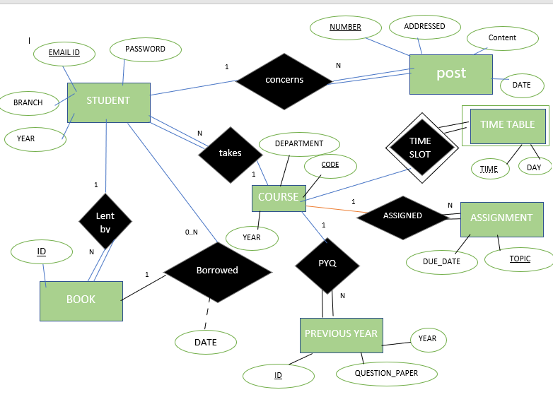

|  |  |  |
| --- | --- | --- |
|  | ER DIAGRAM (UPDATED) |  |

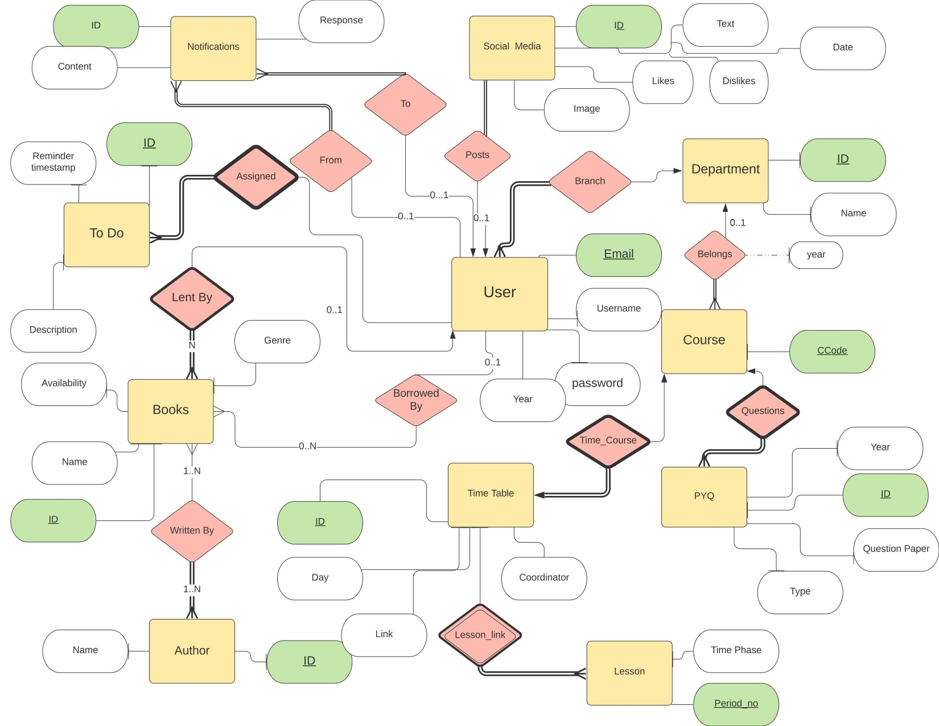

|  |  |  |
| --- | --- | --- |
|  | MAPPING FROM ER TO R |  |

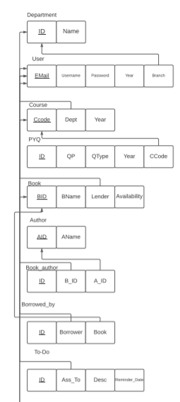

**BRANCH**

**YEAR**

**USERNAME**

**Password**

**REMINDER_DATE**

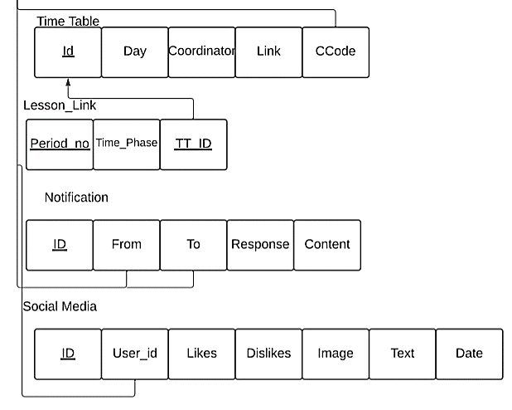

|  |  |  |
| --- | --- | --- |
|  | RELATIONAL SCHEME  (Created through MySQL Workbench) |  |

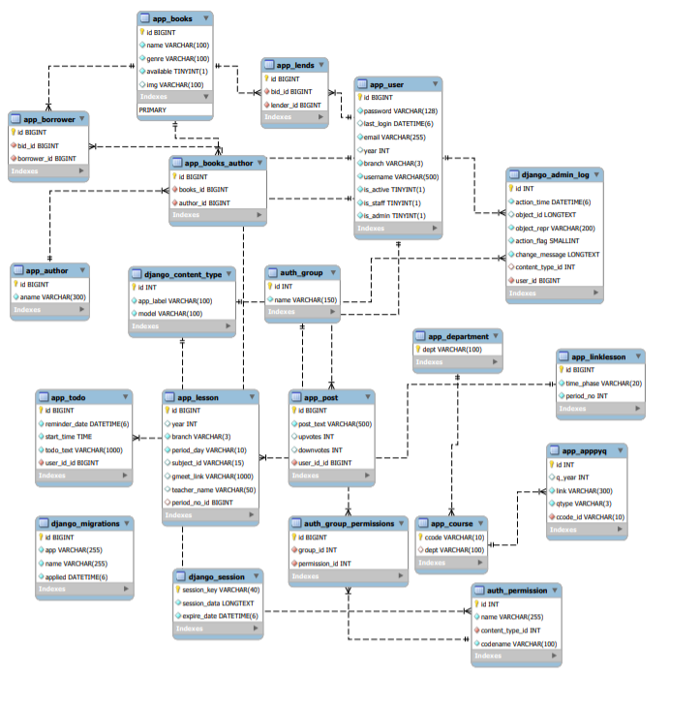

|  |  |  |
| --- | --- | --- |
|  | DATA DICTIONARY |  |

* **User**

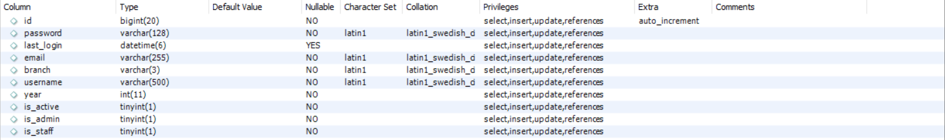

* **Custom Auth User**

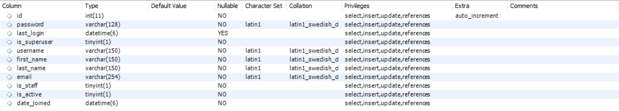

* **Course**



* **Department**



* **Lends**



* **Lesson**

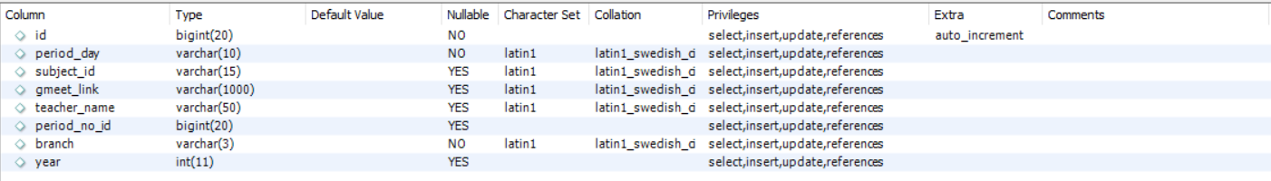

* **Link Lesson**



* 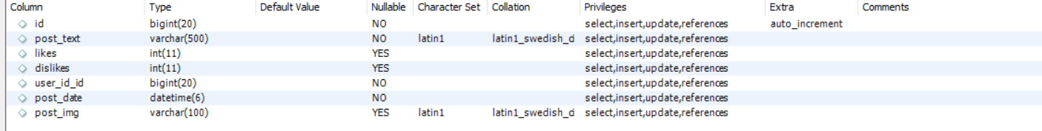**Post**
* **Todo**

|  |  |  |
| --- | --- | --- |
|  | SQL QUERIES |  |

|  |  |  |
| --- | --- | --- |
| OPERATIONS | SAMPLE QUERY | SYNTAX |
| CREATE TABLE | * CREATE TABLE `app_user` ( * `id` bigint(20) NOT NULL AUTO_INCREMENT, * `password` varchar(128) NOT NULL, * `last_login` datetime(6) DEFAULT NULL, * `email` varchar(255) NOT NULL, * `branch` varchar(3) NOT NULL, * `username` varchar(500) NOT NULL, * `year` int(11) NOT NULL, * `is_active` tinyint(1) NOT NULL, * `is_admin` tinyint(1) NOT NULL, * `is_staff` tinyint(1) NOT NULL, * PRIMARY KEY (`id`), * UNIQUE KEY `app_user_email_efde8896_uniq` (`email`) * ) ENGINE=InnoDB AUTO_INCREMENT=15 DEFAULT CHARSET=latin1 | CREATE TABLE ‘table_name’  (  ‘Coloumn name’ conditions); |
| * CREATE TABLE `auth_user` ( * `id` int(11) NOT NULL AUTO_INCREMENT, * `password` varchar(128) NOT NULL, * `last_login` datetime(6) DEFAULT NULL, * `is_superuser` tinyint(1) NOT NULL, * `username` varchar(150) NOT NULL, * `first_name` varchar(150) NOT NULL, * `last_name` varchar(150) NOT NULL, * `email` varchar(254) NOT NULL, * `is_staff` tinyint(1) NOT NULL, * `is_active` tinyint(1) NOT NULL, * `date_joined` datetime(6) NOT NULL, * PRIMARY KEY (`id`), * UNIQUE KEY `username` (`username`) * ) ENGINE=InnoDB AUTO_INCREMENT=3 DEFAULT CHARSET=latin1 |
| * CREATE TABLE `app_course` ( * `ccode` varchar(10) NOT NULL, * `dept` varchar(100) DEFAULT NULL, * PRIMARY KEY (`ccode`), * KEY `app_course_dept_7b74bc89_fk_app_department_dept` (`dept`), * CONSTRAINT `app_course_dept_7b74bc89_fk_app_department_dept` FOREIGN KEY (`dept`) REFERENCES `app_department` (`dept`) * ) ENGINE=InnoDB DEFAULT CHARSET=latin1 |
| * CREATE TABLE `app_department` ( * `dept` varchar(100) NOT NULL, * PRIMARY KEY (`dept`) * ) ENGINE=InnoDB DEFAULT CHARSET=latin1 |
| * CREATE TABLE `app_lends` ( * `id` bigint(20) NOT NULL AUTO_INCREMENT, * `bid_id` bigint(20) NOT NULL, * `lender_id` bigint(20) NOT NULL, * PRIMARY KEY (`id`), * KEY `app_lends_bid_id_46a5924f_fk_app_books_id` (`bid_id`), * KEY `app_lends_lender_id_98cfb9e6_fk_app_user_id` (`lender_id`), * CONSTRAINT `app_lends_bid_id_46a5924f_fk_app_books_id` FOREIGN KEY (`bid_id`) REFERENCES `app_books` (`id`), * CONSTRAINT `app_lends_lender_id_98cfb9e6_fk_app_user_id` FOREIGN KEY (`lender_id`) REFERENCES `app_user` (`id`) * ) ENGINE=InnoDB DEFAULT CHARSET=latin1 |
| * CREATE TABLE `app_linklesson` ( * `id` bigint(20) NOT NULL AUTO_INCREMENT, * `time_phase` varchar(20) NOT NULL, * `period_no` int(11) NOT NULL, * PRIMARY KEY (`id`) * ) ENGINE=InnoDB AUTO_INCREMENT=10 DEFAULT CHARSET=latin1 |
| * CREATE TABLE `app_lesson` ( * `id` bigint(20) NOT NULL AUTO_INCREMENT, * `period_day` varchar(10) NOT NULL, * `subject_id` varchar(15) DEFAULT NULL, * `gmeet_link` varchar(1000) DEFAULT NULL, * `teacher_name` varchar(50) DEFAULT NULL, * `period_no_id` bigint(20) DEFAULT NULL, * `branch` varchar(3) NOT NULL, * `year` int(11) DEFAULT NULL, * PRIMARY KEY (`id`), * KEY `app_lesson_period_no_id_ec141c3e_fk_app_linklesson_id` (`period_no_id`), * CONSTRAINT `app_lesson_period_no_id_ec141c3e_fk_app_linklesson_id` FOREIGN KEY (`period_no_id`) REFERENCES `app_linklesson` (`id`) * ) ENGINE=InnoDB AUTO_INCREMENT=46 DEFAULT CHARSET=latin1 |
| * CREATE TABLE `app_post` ( * `id` bigint(20) NOT NULL AUTO_INCREMENT, * `post_text` varchar(500) NOT NULL, * `likes ` int(11) DEFAULT NULL, * `dislikes ` int(11) DEFAULT NULL, * `user_id_id` bigint(20) NOT NULL, * `post_date` datetime(6) NOT NULL, * `post_img` varchar(100) DEFAULT NULL, * PRIMARY KEY (`id`), * KEY `app_post_user_id_id_c31f0352_fk_app_user_id` (`user_id_id`), * CONSTRAINT `app_post_user_id_id_c31f0352_fk_app_user_id` FOREIGN KEY (`user_id_id`) REFERENCES `app_user` (`id`) * ) ENGINE=InnoDB AUTO_INCREMENT=7 DEFAULT CHARSET=latin1 |
| INSERT | * INSERT INTO app_linklession(id, time_phase, period_no) * VALUES * (1,"8.30-9.30", 1), * (2,"9.30-10.30",2), * (3,"10.30-11.30",3); * (4,"11.30-12.30",4), * (5,"12.30-13.30",5), * (6,"13.30-14.30",6), * (7,"14.30-15.30",7), * (8,"15.30-16.30",8), * (9,"16.30-17.30",9); * INSERT INTO app_lesson(id, period_day, subject_id, gmeet_link, teacher_name, period_no_id,branch, year) * values * (1,'MONDAY', null ,null,null,1,'CSE','2024'), * (2, 'TUESDAY', 'CSL201','https://meet.google.com/tvb-odii-kfu?authuser=0','Dr. SHRUTI GUPTA',1,'CSE','2024'), * (3,'WEDNESDAY', 'ECB204','https://meet.google.com/mch-zvkw-gcq?authuser=0','Dr. NS Singha',1,'CSE','2024'), * (4,'THURSDAY', 'ECB206','https://meet.google.com/nst-jygs-kje?authuser=0&hs=179','Dr. Harikesh',1,'CSE','2024'), * (5,'FRIDAY', null, null, null,1,'CSE','2024'); * (6, 'MONDAY','ECB204','https://meet.google.com/mch-zvkw-gcq?authuser=0','Dr NS Singha', 2,'CSE' ,'2024'), * (7,'TUESDAY', 'MAL241','https://meet.google.com/jqb-bomy-cqo?authuser=0','Dr. P. Kumar',2,'CSE','2024'), * (8,'WEDNESDAY',NULL, null, null,2,'CSE',2024), * (9,'THURSDAY', null,null,null,2,'CSE','2024'), * (10,'FRIDAY', NULL, NULL, NULL,2,'CSE','2024'); * (11, 'MONDAY','ECB204 G1+G2','https://meet.google.com/mch-zvkw-gcq?authuser=0','Dr NS Singha', 3,'CSE' ,2024), * (12,'TUESDAY','CSB202 G2','https://meet.google.com/tyh-qyfz-ekk?authuser=0','Dr S. Sachdeva',3,'CSE','2024'), * (13,'WEDNESDAY','CSL201','https://meet.google.com/tvb-odii-kfu?authuser=0','Dr. SHRUTI GUPTA',3,'CSE','2024'), * (14,'THURSADAY',null, null, null,3,'CSE','2024'), * (15,'FRIDAY','CSL203','https://meet.google.com/hiv-jjae-pvo?authuser=0&hs=179', 'Dr. Rohini Mahajan',3,'CSE','2024'); * (16, 'MONDAY','ECB204 G1+G2','https://meet.google.com/mch-zvkw-gcq?authuser=0','Dr NS Singha', 4,'CSE' ,2024), * (17,'TUESDAY','CSB202 G2','https://meet.google.com/tyh-qyfz-ekk?authuser=0','Dr S. Sachdeva',4,'CSE','2024'), * (18,'WEDNESDAY','CSL203','', 'Dr. Rohini Mahajan',4,'CSE','2024'), * (19,'THURSDAY', 'CSB202','https://meet.google.com/tyh-qyfz-ekk?authuser=0','Dr S. Sachdeva',4,'CSE','2024'), * (20,'FRIDAY', 'CSB202 G1','https://meet.google.com/tvb-odii-kfu?authuser=0','Dr S. Sachdeva',4,'CSE','2024'); * (21, 'MONDAY','CSL201','https://meet.google.com/tvb-odii-kfu?authuser=0','Dr. SHRUTI GUPTA',5,'CSE','2024'), * (22,'TUESDAY','CSB202 G1','https://meet.google.com/tvb-odii-kfu?authuser=0','Dr S. Sachdeva',5,'CSE','2024'), * (23, 'WEDNESDAY',NULL, NULL, NULL, 5 , 'CSE','2024'), * (24,'THRUSDAY',NULL,NULL,NULL,5,'CSE','2024'), * (25,'FRIDAY','CSB202 G1','https://meet.google.com/tvb-odii-kfu?authuser=0','Dr S. Sachdeva',5,'CSE','2024'); * (26,'MONDAY',NULL,NULL,NULL,6,'CSE',2024), * (27,'TUESDAY',NULL,NULL,NULL,6,'CSE',2024), * (28,'WEDNESDAY',NULL,NULL,NULL,6,'CSE',2024), * (29,'THURDAY','CSL201','https://meet.google.com/tvb-odii-kfu?authuser=0','Dr. SHRUTI GUPTA',6,'CSE','2024'), * (30,'FRIDAY', 'ECB204','https://meet.google.com/mch-zvkw-gcq?authuser=0','Dr. NS Singha',6,'CSE','2024'), * (31,'MONDAY','CSB202 ','https://meet.google.com/tvb-odii-kfu?authuser=0','Dr S. Sachdeva',7,'CSE','2024'), * (32,'TUESDAY','MAL241','https://meet.google.com/jqb-bomy-cqo?authuser=0','Dr. P. Kumar',7,'CSE','2024'), * (33,'WEDNESDAY','ECB206','https://meet.google.com/nst-jygs-kje?authuser=0&hs=179','Dr. Harikesh',7,'CSE','2024'), * (34,'THURSDAY','CSL203','https://meet.google.com/hiv-jjae-pvo?authuser=0&hs=179', 'Dr. Rohini Mahajan',7,'CSE','2024'), * (35,'FRIDAY', NULL,NULL,NULL,7,'CSE',2024), * (36,'MONDAY', NULL,NULL,NULL,8,'CSE',2024), * (37,'TUESDAY', 'ECB206','https://meet.google.com/nst-jygs-kje?authuser=0&hs=179','Dr. Harikesh',8,'CSE','2024'), * (38,'WEDNESDAY','MAL241','https://meet.google.com/jqb-bomy-cqo?authuser=0','Dr. P. Kumar',8,'CSE','2024'), * (39,'THURSDAY','MAL241','https://meet.google.com/jqb-bomy-cqo?authuser=0','Dr. P. Kumar',8,'CSE','2024'), * (40,'FRIDAY','ECB206 G1+G2','https://meet.google.com/nst-jygs-kje?authuser=0&hs=179','Dr. BALJIT KAUR',8,'CSE','2024'), * (41,'MONDAY', NULL,NULL,NULL,9,'CSE',2024), * (42,'TUESDAY','CSL203','https://meet.google.com/hiv-jjae-pvo?authuser=0&hs=179', 'Dr. Rohini Mahajan',9,'CSE','2024'), * (43,'WEDNESDAY', NULL,NULL,NULL,9,'CSE',2024), * (44,'THURSDAY', NULL,NULL,NULL,9,'CSE',2024), * (45,'FRIDAY', 'ECB206 G1+G2','https://meet.google.com/nst-jygs-kje?authuser=0&hs=179','Dr. BALJIT KAUR',9,'CSE','2024'); | INSERT INTO *TABLE_NAME*(*ATTRIBUTES)*  VALUES  ( ) |
|  | * insert into app_department * values * ("CSE"),("ECE"),("EEE"),("HUM"),("ASC"); |  |
|  | * insert into app_course * values * ("MAL241","ASC"),("ECB206","ECE"),("CSL201","CSE"),("ECB204","ECE"),("CSL203","CSE"),("CSB202","CSE"),("ECB201","ECE"),("EEL201","EEE"), * ("ECB202","ECE"),("ECL203","ECE"); |  |
|  | * insert into app_apppyq * values * (1,2019,"https://drive.google.com/file/d/1oj2lIKbvlKzf-88L4gqeYkvCcGLOs0v2/view?usp=sharing","MAL241","ES"), * (2,2019,"https://drive.google.com/file/d/1oj2lIKbvlKzf-88L4gqeYkvCcGLOs0v2/view?usp=sharing","MAL241","ES"), * (3,2018,"https://drive.google.com/file/d/1wOduct3a83F2d61vUPnxrGrTcxOHBlXZ/view?usp=sharing","MAL241","ES"), * (4,2018,"https://drive.google.com/file/d/1m_1TRSRcaQv7thFfqWy365ifncthFTM2/view?usp=sharing","MAL241","MS"), * (5,2019,"https://drive.google.com/file/d/1woaXQLez0BC5Sl8aDgQ5XVvIB80Z7EQI/view?usp=sharing","ECB206","ES"), * (6,2019,"https://drive.google.com/file/d/18VMgsK3-EuZt1RUOh7k8wOleHmh9kuBZ/view?usp=sharing","ECB206","MS"), * (7,2018,"https://drive.google.com/file/d/1lamW80fk6rdnoiawygxX1Hql2oR_R10u/view?usp=sharing","ECB206","ES"), * (8,2018,"https://drive.google.com/file/d/1lX9MIDK3NJWGckYCxP29XiOwusH0blUS/view?usp=sharing","ECB206","MS"), * (9,2019,"https://drive.google.com/file/d/12EKb_yDqraqjOxt5-WjlDtBr5mQB-hKc/view?usp=sharing","CSL201","ES"), * (10,2019,"https://drive.google.com/file/d/1IxIPfWHONliaRq5O0GnrVX2h-lSump0K/view?usp=sharing","CSL201","MS"), * (11,2018,"https://drive.google.com/file/d/1PYk6-0dWiIZUk6vcN0Yf3YKLF-SH4Tvk/view?usp=sharing","CSL201","ES"), * (12,2018,"https://drive.google.com/file/d/1Q0Kr65fAPmXzotOD8RYxcJcBb-UC4sbL/view?usp=sharing","CSL201","MS"), * (13,2019,"https://drive.google.com/file/d/16-2G5mXftykomRt7A4L26jqi4P-buGaO/view?usp=sharing","CSB202","ES"), * (14,2019,"https://drive.google.com/file/d/1fvn1Ora2QHJMLcpB2lGOxdAgCr6A2EMy/view?usp=sharing","CSB202","MS"), * (15,2018,"https://drive.google.com/file/d/1UNlzULDbNBB9AV2E9I5QUlmEmDDPrlcC/view?usp=sharing","CSB202","ES"), * (16,2018,"https://drive.google.com/file/d/1tStGHFJgj6M2iC2ANKGqZVfRsPJYCM-d/view?usp=sharing","CSB202","MS"), * (17,2019,"https://drive.google.com/file/d/1LjxjWjs48pg48qiZRO1W6MVrtXnY1kdV/view?usp=sharing","ECB204","ES"), * (18,2019,"https://drive.google.com/file/d/1p4-wzEVTlMmu_By2ozr59f3SejkvIEV0/view?usp=sharing","ECB204","MS"), * (19,2018,"https://drive.google.com/file/d/1ERnGM7IpVPpUowlhF-L3v7crr_BywWtH/view?usp=sharing","ECB204","ES"), * (20,2018,"https://drive.google.com/file/d/13ALuxoTyawL_y633z3utDrbD5tNpjUu2/view?usp=sharing","ECB204","MS"), * (21,2019," https://drive.google.com/file/d/1ghcZuFVriJTNnj6a7y0J5LR8otCdWdpR/view?usp=sharing","CSL203","ES"), * (22,2019,"https://drive.google.com/file/d/1s4kVL7Y01gNzCw8gBoEA-56pJkUWgssq/view?usp=sharing ","CSL203","MS"), * (23,2018,"https://drive.google.com/file/d/1Zb_3-jZzFsiyO6sbZDXllVuMyf2hMgM6/view?usp=sharing ","CSL203","ES"), * (24,2018,"https://drive.google.com/file/d/1es4M7vCsVbpX23qg-JThxoS2uy2M_c6A/view?usp=sharing ","CSL203","MS"), * (25,2019,"https://drive.google.com/file/d/1qMuqmtgYAufx-0STmMeH4OQKj9PUeH2n/view?usp=sharing","ECB201","ES"), * (26,2019,"https://drive.google.com/file/d/15LxuHvytrLiehN5v60COH18tOxhZS8oy/view?usp=sharing","ECB201","MS"), * (27,2018,"https://drive.google.com/file/d/1VG4oAKUeKxFYYVk_IcOooY0l_lI6icuz/view?usp=sharing","ECB201","ES"), * (28,2018,"https://drive.google.com/file/d/100_oZBQQ-Ps5_u9pa3YDMlgYNMietvee/view?usp=sharing","ECB201","MS"), * (29,2019,"https://drive.google.com/file/d/1NIidiM440YLyth-YcQTKVL2mzfbvaLRI/view?usp=sharing","EEL201","ES"), * (30,2019,"https://drive.google.com/file/d/1UZXiMDeQM8CQM9f7X9CJCDNOP9TlZesW/view?usp=sharing","EEL201","MS"), * (31,2018,"https://drive.google.com/file/d/1QtZ6z89tNF8ThynCGv6uVrMZ6hUlhSsT/view?usp=sharing","EEL201","ES"), * (32,2018,"https://drive.google.com/file/d/1JrP-VNzxeYTndXTI6WtOhxtgscf7HGwL/view?usp=sharing","EEL201","MS"), * (33,2019,"https://drive.google.com/file/d/1gJbyr9zbWGSvNARyx53T_eJF-7ux23WV/view?usp=sharing","ECB202","ES"), * (34,2019,"https://drive.google.com/file/d/1KqzNp5jvZW6I_jDINlwA0ehcF66FmfVd/view?usp=sharing","ECB202","MS"), * (35,2018,"https://drive.google.com/file/d/1OlchpYEVoNX5fsR6alLD20Z7FhYROOPf/view?usp=sharing","ECB202","ES"), * (36,2018,"https://drive.google.com/file/d/1JXMPaEG_5jrb_RPMUrPSxC0lgpyu0RSy/view?usp=sharing","ECB202","MS"), * (37,2019,"https://drive.google.com/file/d/1tPu0tzol1KT4VmIh9PwnDTvx5y6mhGC2/view?usp=sharing","ECL203","ES"), * (38,2019,"https://drive.google.com/file/d/1LNpwVu6vFjH-BbH1TJaO2fBEew3_Bkr1/view?usp=sharing","ECL203","MS"), * (39,2018,"https://drive.google.com/file/d/12I_hpnurvlbx_htmnq63QlGgJMdpRzf8/view?usp=sharing","ECL203","ES"), * (40,2018,"https://drive.google.com/file/d/1BuYj_BLA6j4DmF6HKXvpVba2B6MGL_c2/view?usp=sharing","ECL203","MS"); |  |
| SELECT | * **SELECT** YEAR, QUESTIONPAPER, TYPE, * FROM PYQ * WHERE PYQ.code = request.value | Select  *coloumn_name*  FROM  *Table_name*  Where  *Desired conditions* |
| **Select** *  from app_notification  where receiver_id=1 |
| * **Select** reminder, timestamp, description * From todo * Where todo.user_id = request.user.id |
| Delete | **Delete** from app_todo  where id=1 | Delete from *table name*  Where *condition* |
| **Delete** from app_notification  where id=1 |
| **Delete** from app_lender  where id=1 |

**Advanced Queries**

|  |  |  |
| --- | --- | --- |
| OPERATION | SAMPLE QUERY | SYNTAX |
| Nested Inner Join  (To project name,author and genre as searched by a user) | **select** name,aname,genre  **from** app_author **inner join** (app_books **inner join** app_books_author on app_books.id=app_books_author.books_id) on app_author.id=app_books_author.author_id  **where** app_books.name like "%Algebra%" and app_books.available=1; | SELECT column_name(s)  FROM table1  INNER JOIN  (table2  INNER JOIN  table3  ON table1.column_name = table2.column_name)ON table1.column_name = table2.column_name; |
| π(name,aname,genre)  (app_author ⋈ <app_author.ID=app_books_author.books_id>(app_books_author ⋈ <app_books_author.books_id=app_books.id> (σ <name=”Algebra”>(app_books)) | | |
|  |  | |
| (To project period_day, subject_id, gmeet_link and teacher name depending upon the branch of user) | **select** **distinct**(time_phase) period_day,subject_id,gmeet_link,teacher_name  **from** app_linklesson **inner join** (app_lesson **inner join** app_user on app_user.branch=app_lesson.branch) on app_linklesson.period_no=app_lesson.period_no_id  **where** period_day="Monday" and app_user.branch="CSE"; |  |
| π(time_phase,period_day,subject_id,gmeet_link,teacher_name)  (app_linklesson ⋈ <app_linklesson.period_no=app_lesson.period_no_id>(app_lesson ⋈ <app_user.branch=app_lesson.branch> (σ <period_day=”Monday” ∩ app_user.branch="CSE"  >(app_books)) | | |
|  |  | |
| Union  (To project details of book if user searches by book name or author name) | **select** name,aname,genre  **from** app_author **inner join** (app_books **inner join** app_books_author on app_books.id=app_books_author.books_id) on app_author.id=app_books_author.author_id  **where** app_books.name like "%Algebra%" and app_books.available=1  **union**  **select** name,aname,genre  **from** app_books **inner join**(app_author **inner join** app_books_author on app_author.id=app_books_author.author_id)on app_books.id=app_books_author.id  **where** app_author.aname like "%jay Abramson%" and app_books.available=1; | SELECT column_name(s) FROM table1  UNION  SELECT column_name(s) FROM table2; |
|  |  | |
| Left Outer Join | **select** app_user.id, email, username, bid_id  **from** app_user left outer join app_borrower on app_user.id=app_borrower.borrower_id; | SELECT column_name(s)  FROM table1  LEFT OUTER JOIN table2  ON table1.column_name = table2.column_name; |
| (To project the borrowed record of each user) | π(app_user.id,email,username,bid_id)  (app_user  <app_user.id=app_borrower.borrower_id> app_borrower) | |
| (To project the lent record of each user) | **select** app_user.id, email, username, bid_id  **from** app_user **left outer join** app_lends  **on** app_user.id=app_lends.lender_id**;** | |
| π(app_user.id,email,username,bid_id)  (app_user  <app_user.id=app_lends.lender_id> app_lends) | | |
| INNER JOIN | **SELECT** app_todo.todo_text, app_todo.reminder_date, app_user.email, app_user.username  **FROM** app_todo  **INNER JOIN** app_user on app_todo.user_id_id = app_user.id; | SELECT column_name(s)  FROM table1  INNER JOIN table2  ON table1.column_name = table2.column_name; |
| (To project the text, reminder date  Of a user) | π(app_todo.todo_text, app_todo.reminder_date, app_user.email, app_user.username)  (app_todo ⋈<app_todo.user_id_id = app_user.id> app_user) | |
|  | **SELECT** app_user.username, app_user.email, app_post.post_text  **FROM** app_user  **INNER JOIN** app_post **ON** app_post.user_id_id = app_user.id; |  |
| (To project the text of post, username and email of the user who have posted ) | π(app_user.username, app_user.email, app_post.post_text)  (app_user ⋈<app_post.user_id_id = app_user.id> app_post) | |
| (To print book id of the books a user has lent) | **select** app_user.id, email, username, bid_id  **from** app_user **inner join** app_lends  on app_user.id=app_lends.lender_id  **where** app_user.id=1; | |
| π(app_user.id, email, username, bid_id)  (app_user ⋈<on app_user.id=app_lends.lender_id>σ <app_user.id=1> (app_lends)) | | |

|  |  |  |
| --- | --- | --- |
|  | POPULATED TABLES |  |

SELECT * FROM project_dbms.app_user;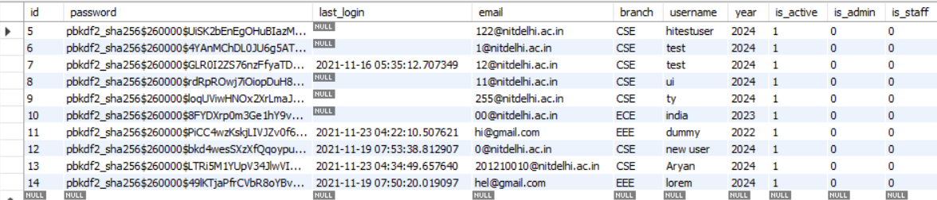

SELECT * FROM project_dbms.auth_user;



SELECT * FROM project_dbms.app_apppyq;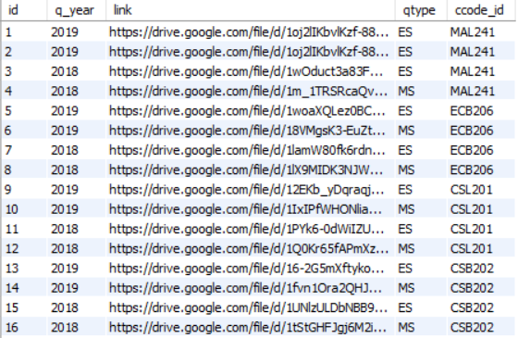

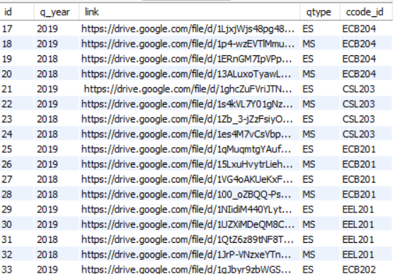

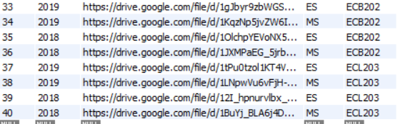

SELECT * FROM project_dbms.app_author;

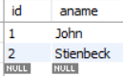

SELECT * FROM project_dbms.app_books_author;

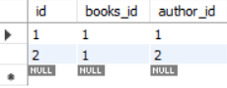

SELECT * FROM project_dbms.app_department;

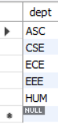

SELECT * FROM project_dbms.app_lends;

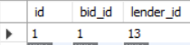

SELECT * FROM project_dbms.app_lesson;

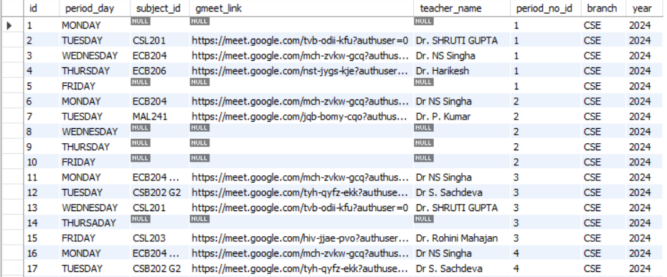

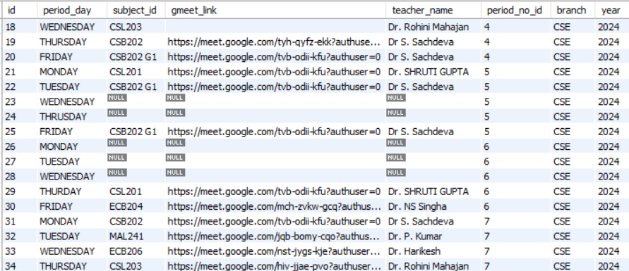

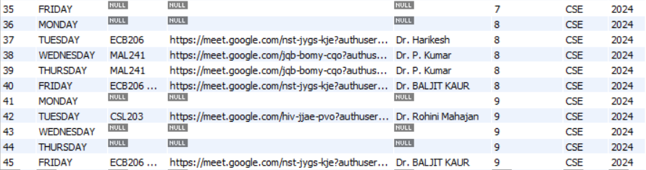

SELECT * FROM project_dbms.app_linklesson;

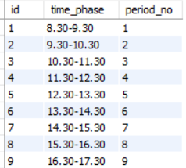

SELECT * FROM project_dbms.app_post;

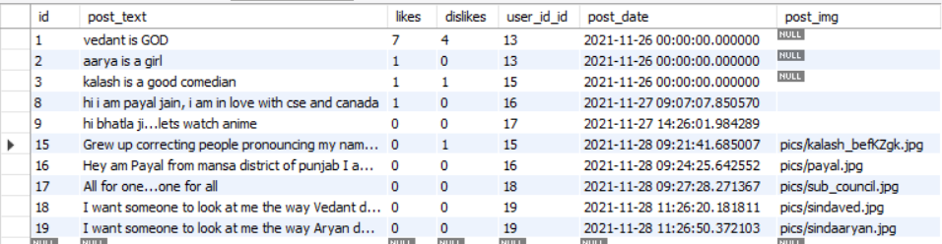

SELECT * FROM project_dbms.app_todo;

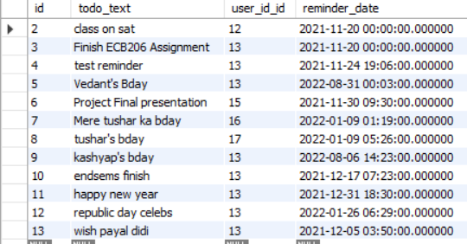

|  |  |  |
| --- | --- | --- |
|  | DATABASE CONNECTIVITY |  |

|  |  |
| --- | --- |
|  | **The database has been connected to the frontend user interface using PYTHON 3.9.7.**  **The code for establishing the connection is as follows:**  DATABASES = {      'default': {          'ENGINE': 'django.db.backends.mysql',          'NAME': 'project_dbms',          'USER': 'root',          'PASSWORD': '123456',          'PORT': 3306,          'HOST': '127.0.0.1'      }  }  **The above code serves to establish a secure connection between the backend (database made on MySQL) and frontend (user-interface)**  **The Python 3.9.7 codes correspond to each functionality being implemented are mentioned along with the respective functionality in the following pages.** |

|  |  |  |
| --- | --- | --- |
|  | FUNCTIONALITY |  |

**Below are the functionalities that are implemented in the project along with the necessary HTML and Python 3.9.7 codes**

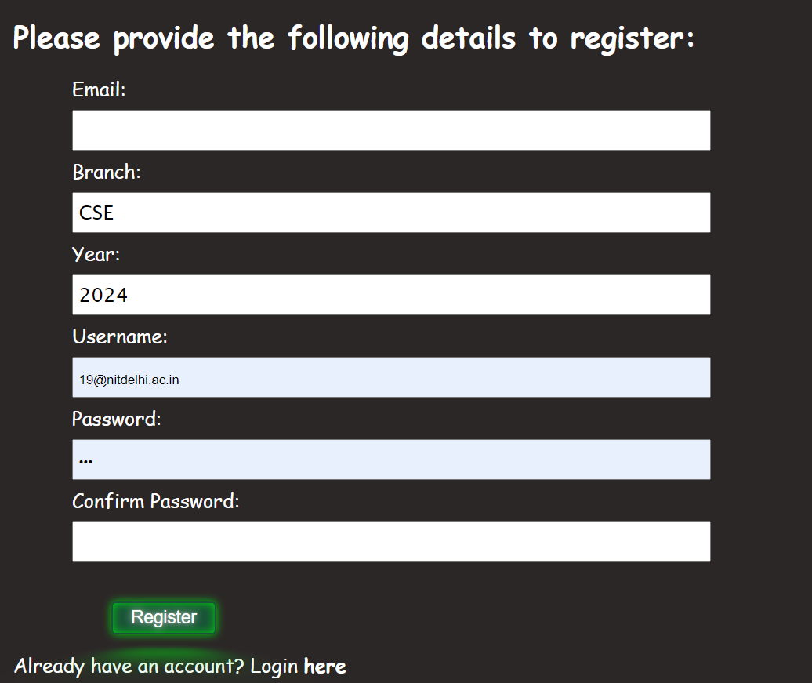Register Page

***in html***

                <form *action*="register" *id*="stud_deet" *method*="post">

                    {% csrf_token %}

                    {{form}}

                    <button *type*="submit" *class*="btn">Register</button>

               </form>

***In forms.py***

class RegisterForm(*forms*.*ModelForm*):

    password = forms.CharField(*widget*=forms.PasswordInput)

    password_2 = forms.CharField(*label*='Confirm Password', *widget*=forms.PasswordInput)

    class Meta:

        model = User

        fields = ['email', 'branch', 'year', 'username']

    def clean_email(*self*):

        '''

        Verify email is available.

        '''

        email = *self*.cleaned_data.get('email')

        qs = User.user_obj.filter(*email*=email)

        if qs.exists():

            raise forms.ValidationError("email is taken")

        return email

    def clean(*self*):

        '''

        Verify both passwords match.

        '''

        data = *self*.cleaned_data

        password = *str*(*self*.cleaned_data.get("password"))

        password_2 = *str*(*self*.cleaned_data.get("password_2"))

        if password != password_2:

            raise forms.ValidationError("Passwords don't match")

        return data

    def save(*self*, *commit*=True):

        # Save the provided password in hashed format

        user = *super*().save(*commit*=False)

        user.set_password(*self*.cleaned_data["password"])

        if commit:

            user.save()

        return user

***in views.py***

def register(*request*):

    if request.method == 'POST':

        form = RegisterForm(request.POST)

        if form.is_valid():

            form.save()

            return redirect ('login')

        else:

            form =RegisterForm(request.POST)

            return render(request, 'register.html', {"form":form})

    else:

        form = RegisterForm()

        return render(request, 'register.html', {"form":form})

***in urls.py***

urlpatterns = [

    path("register", views.register, *name*="register"),

]

Verification of email

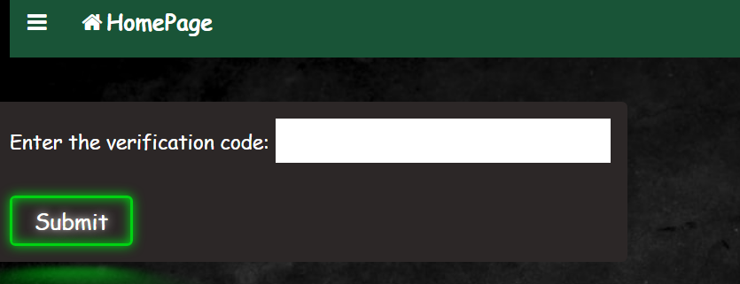

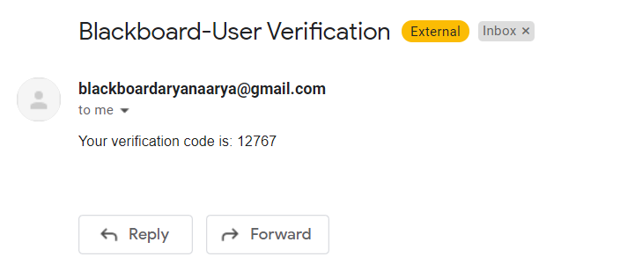

***In html***

                    <form *action*="verification" *method*="POST">

                        {% csrf_token %}

                        <label *for*="v_code" *class*="labels">Enter the verification code:</label>

                        <input *type*="text" *class*="inputs" *name*="code" *style*="height:40px;" *required*><br><br>

                        <button *type*="submit" *class*="neon-button">Submit</button>

                    </form>

***In views.py***

def sendmail(*mail*):

    import smtplib,random

    from email.message import EmailMessage

    mail=*str*(student.cleaned_data['email'])

    code=*str*(random.randint(10000,99999))

    global vcode

    vcode=code

    content="Your verification code is: "+code

    msg = EmailMessage()

    msg.set_content(content)

    msg['Subject'] = 'Blackboard-User Verification '

    msg['From'] = "blackboardaryanaarya@gmail.com"

    msg['To'] = mail

     # Send the message via our own SMTP server.

    server = smtplib.SMTP_SSL('smtp.gmail.com', 465)

    server.login("blackboardaryanaarya@gmail.com", "aaryadurba")

    server.send_message(msg)

    server.quit()

Login Page

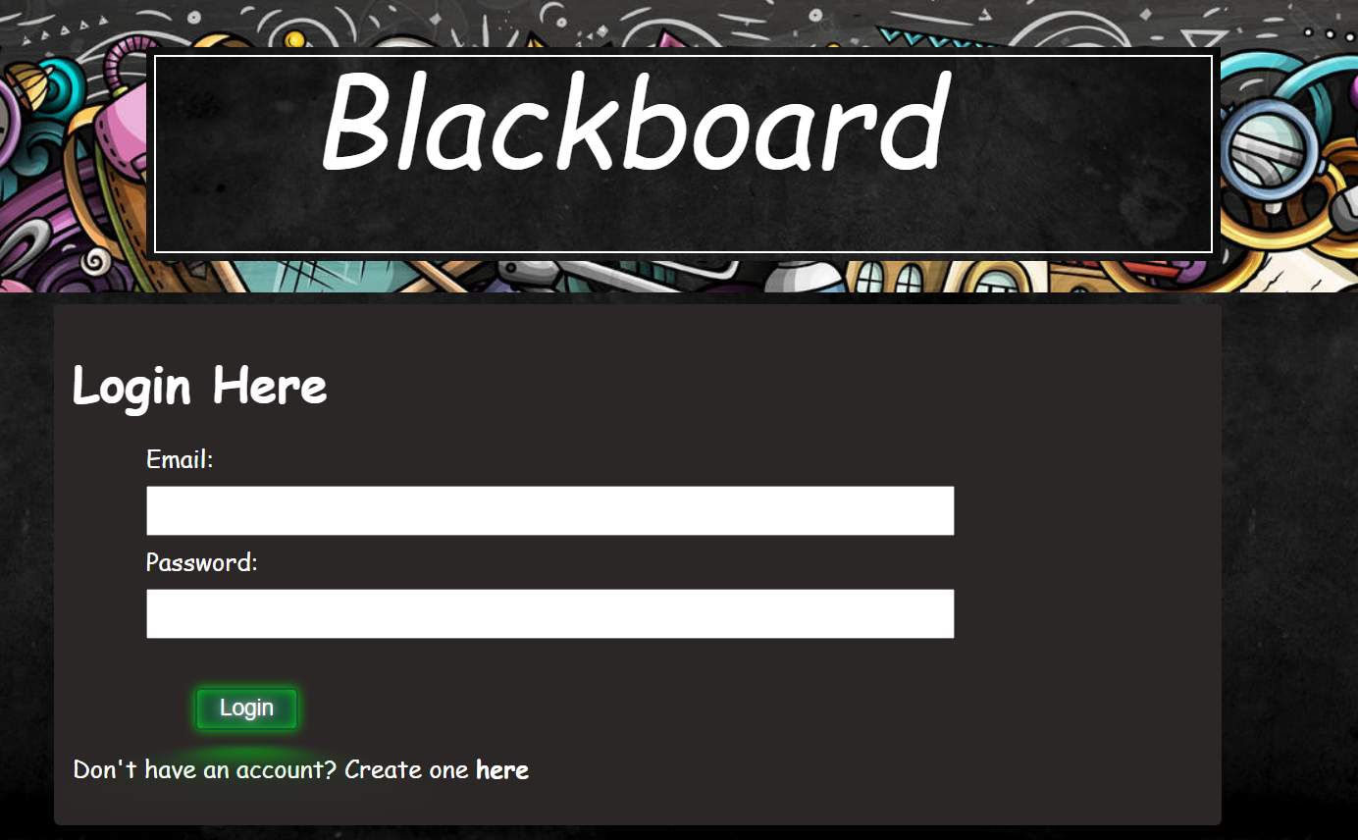

***In html***

<form *method*="post" *class*="form-group">

    {% csrf_token%}

    {{form}}

    <button *type*="submit" *class*="btn btn-success">Login </button>

    <p>Don't have an account? Create one <a *href*="/register"> here</a></p>

</form>

***In hosting/urls.py***

urlpatterns = [

    path('', include('django.contrib.auth.urls')),

]

***In settings.py***

LOGIN_REDIRECT_URL = '/home'

Logout Function

***In html***

<a *href*="logout"><i *class*="fa fa-fw fa-user"></i>LogOut</a>

***In hosting/urls.py***

urlpatterns = [

    path('', include('django.contrib.auth.urls')),

]

***In settings.py***

LOGOUT_REDIRECT_URL = '/home'

Previous Year Question Paper

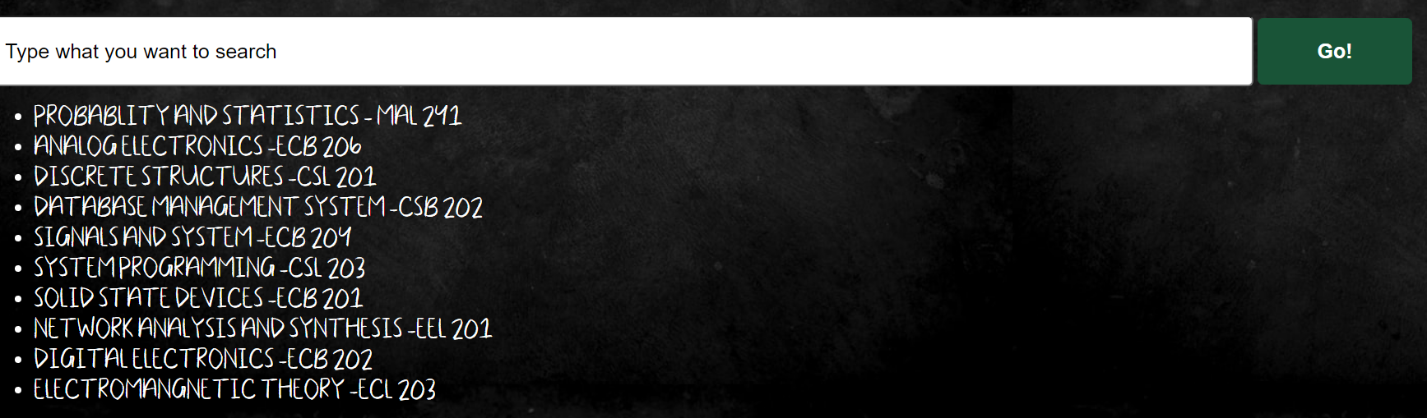



***In html***

{% for result in qp %}

<div *id*="items">

        <p>Course Code: {{result.ccode.ccode}}</p>

        <p>Year: {{result.q_year}}</p>

        <p>Type: {{result.qtype}}</p>

        <p>Link: To view the file click <a *href*="{{result.link}}"  *style*="text-decoration:none; color:white; font-weight:bold;" *target*="_blank"> here</a></p>

</div>

{% endfor %}

<script>

    var x="{{qp}}";

    console.log(x=="&lt;QuerySet []&gt;")

    if (document.getElementById("items")==null){

        var newel=document.createElement("p");

        newel.innerHTML="Didn't find a match. Please check the course code";

        newel.style.color="white";

        newel.style.fontSize="x-large";

        document.body.appendChild(newel);

    }

</script>

***In views.py***

def pyq(*request*):

    if request.user.is_authenticated:

        print('user is authenticated')

        if request.method=="POST":

            searched=request.POST['searched']

            searched=searched.strip()

            datas = AppPYQ.objects.filter(*ccode__ccode__icontains*=searched)

            for data in datas:

                data.link=*str*(data.link).strip()

                data.q_year=*str*(data.q_year).strip()

                data.qtype=*str*(data.qtype).strip()

                data.qtype="End Semester" if data.qtype=="ES" else "Mid Semester"

            return render(request, 'pyq.html',{"qp":datas})

        return render(request, 'pyq.html')

    else:

        return redirect('/')

***in urls.py***

urlpatterns = [

    path("pyq", views.pyq, *name*="pyq"),

]

***In models.py***

class AppPYQ(*models*.*Model*):

    id=models.IntegerField(*primary_key*=True)

    q_year=models.IntegerField(*blank*=True,*null*=True)

    link=models.CharField(*max_length*=3000)

    ccode=models.ForeignKey(AppCourse,*on_delete*=models.DO_NOTHING)

    qtype=models.CharField(*max_length*=10)

TODO

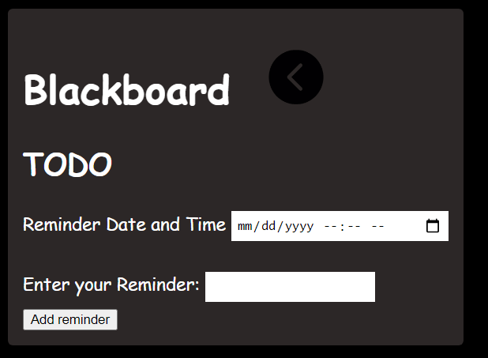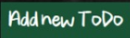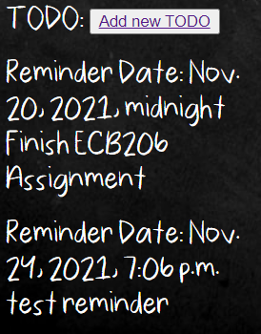

***in html***

* <form *action*="/todo_fn" *id*="stud_deet" *method*="post">
* {% csrf_token %}
* <label *for* = "reminder_date", *class* = "labels">Reminder Date and Time</label>
* <input *type* ='datetime-local' *class*='inputs' *name*='reminder_date' *id*='reminder_date'>
* <br><br>
* <label *for* = 'todo_text' *class*='labels'>Enter your Reminder: </label>
* <input *type*= "text" *class*="inputs" *name* = 'todo_text' *width* = 75 *px*, *height*= 250 *px*>
* <br>
* <button *type* "submit"> Add reminder </button>
* </form>

<p>TODO: <button *type*="submit"><a *href* = "/todo_fn">Add new TODO</button></a></p>

{%for j in todo_cse%}

<p>Reminder Date: {{j.reminder_date}}<br>

{{j.todo_text}}</p>

{% endfor %}

<br><br>

***in models.py***

class todo (*models*.*Model*):

    user_id = models.ForeignKey(User, models.DO_NOTHING)

    reminder_date = models.DateTimeField(*auto_now_add*=False, *auto_now* = False, *null* = False, *default*= None)

    todo_text = models.CharField(*max_length*=1000)

***in views.py***

def todo_fn(*request*):

    if request.user.is_authenticated:

        if request.method == 'POST':

            reminder_date = request.POST.get('reminder_date')

            todo_text = request.POST.get('todo_text')

            print("hi i am here")

            notif_todo = todo(*user_id*=request.user, *reminder_date*=reminder_date ,*todo_text*=todo_text)

            notif_todo.save()

            return redirect('home')

    else:

        return redirect('/')

    return render(request, 'todo.html')

***in urls.py***

urlpatterns = [

    path("home", views.home, *name*="home"),]

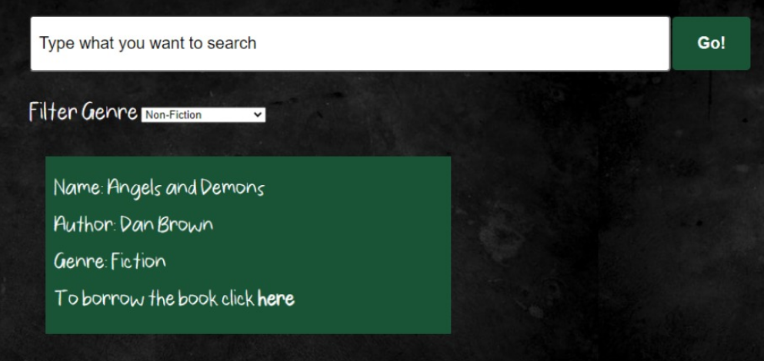Search BOOK

***In html***

<form *action*="search_book" *method*="POST">  {% csrf_token %}

    <input *name*="searched" *type*="text" *id*="search_bar" *class*="js-userinput container-textinput" *onclick*="document.getElementById('search_bar').value='' " *placeholder*="Type what you want to search"/><br><br>

    <label *for*="genre" *class*="labels filter">Filter Genre</label>

    <select *name*="genre" *class*="inputs drop_down">

        <option *value*="NF">Non-Fiction</option>

        <option *value*="F">Fiction</option>

        <option *value*="Th">Thriller</option>

        <option *value*="AA">Action and Adventure</option>

        <option *value*="C">Comic</option>

        <option *value*="BG">Biographies</option>

        <option *value*="CLB">College Books</option>

    </select>

<button *type*="submit" *class*="js-go container-button search_btn" >Go!</button>

</form>

<div *id*="result" *class*="content" *style*="height:100%; width:100%; ">

    {% for result in bk %}

    <div *id*="book" *class*="books" *name*="{{result.id}}">

            <p>Name: {{result.name}} </p>

            {% for author in result.author.all %}

            <p>Author: {{author.aname}}</p>

            {% endfor %}

***in models.py***

class author(*models*.*Model*):

    aname=models.CharField(*max_length*=300)

    class Meta:

        ordering=['aname']

Add Book

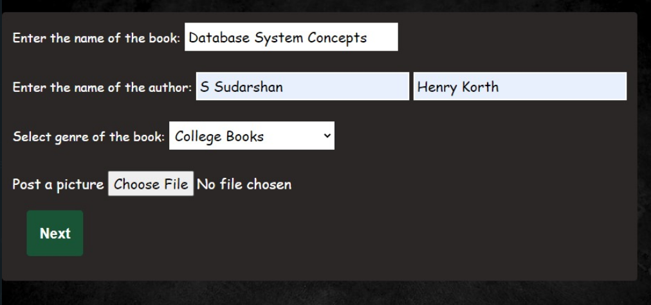

***In html***

<form *action*="addbook" *method*="POST">

    {% csrf_token %}

    <label *for*="book_name" *class*="labels">Enter the name of the book:</label>

    <input *type*="text" *class*="inputs" *name*="book_name"  *required*><br><br>

    <label *for*="aname1" *class*="labels">Enter the name of the author:</label>

    <input *type*="text" *class*="inputs" *name*="aname1" *placeholder*="First Author" *required*>

    <input *type*="text" *class*="inputs" *name*="aname2" *placeholder*="Second Author"><br><br>

    <label *for*="genre" *class*="labels">Select genre of the book: </label>

    <select *name*="genre" *class*="inputs select">

        <option *value*="NF">Non-Fiction</option>

        <option *value*="F">Fiction</option>

        <option *value*="Th">Thriller</option>

        <option *value*="AA">Action and Adventure</option>

        <option *value*="C">Comic</option>

        <option *value*="BG">Biographies</option>

        <option *value*="CLB">College Books</option>

    </select><br><br>

    <label *for*="myfile">Post a picture</label>

    <input *type*="file" *name*="picture"><br>

    <button *type*="submit" *class*="container-button next">Next</button>

</form>

***In models.py***

genre_choices=[

    ('NF','Non-Fiction'),

    ('F','Fiction'),

    ('Th','Thriller'),

    ('AA','Acrion and Adventure'),

    ('C','Comic'),

    ('BG','Biographies and Autobiographies'),

    ('CLB','College Level Books'),

]

class Books(*models*.*Model*):

    name=models.CharField(*max_length*=100)

    author=models.ManyToManyField(author)

    genre=models.CharField(*max_length*=100,*choices*=genre_choices,*default*='CLB')

    available=models.BooleanField(*default*=True)

    img=models.ImageField(*upload_to*='pics',*null*=True)

Confirmation of Book Borrow

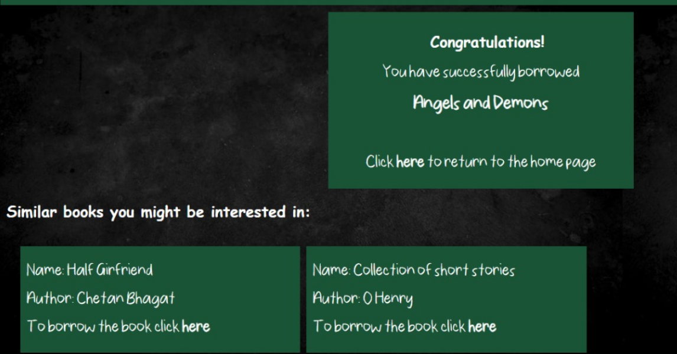

***In models.py***

class Lends(*models*.*Model*):

    bid=models.ForeignKey(Books, *on_delete*=models.DO_NOTHING)

    lender=models.ForeignKey(User, *on_delete*=models.DO_NOTHING)

Social Media Adding post

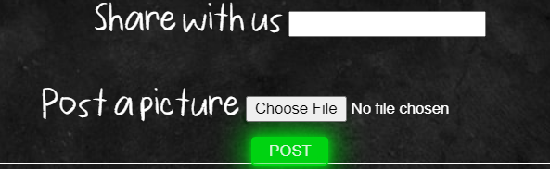

***In html***

        <form *action*="/sm_pg2" *id*="stud_deet" *method*="post" *enctype*="multipart/form-data">

                {% csrf_token %}

                    <label *for*="post" *class*="labels">Share with us</label>

                    <input *type*="text" *class*="inputs" *name*="post_text"*required* ><br><br>

                    <label *for*="myfile">Post a picture</label>

                    <input *type*="file" *name*="post_img"><br>

                    <button *type* "submit" *class* = "neon-button"> POST </button>

                </form>

***in models.py***

class post(*models*.*Model*):

    user_id =  models.ForeignKey(User, models.DO_NOTHING)

    post_text = models.CharField(*max_length*=500)

    post_date = models.DateTimeField((u"Conversation Date"), *auto_now_add*=True, *blank*=True)

    post_img=models.ImageField(*upload_to*='pics',*null*=True)

    likes=models.IntegerField(*max_length*=1000, *default*=0, *null* = True)

    dislikes=models.IntegerField(*max_length*=1000, *default*=0, *null* = True)

Book Transaction Histories

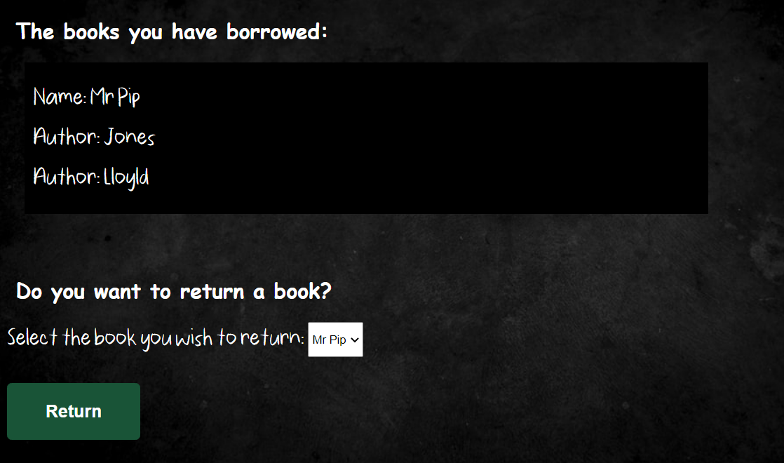

*In html*

  </form>

                {%endif%}

                {% if borrowed %}

                <br><h2>The books you have borrowed:</h2>

                {% for bb in borrowed %}

                <div *class*="books">

                <p>Name: {{bb.bid.name}}</p>

                {% for author in bb.bid.author.all %}

                         <p>Author: {{author.aname}}</p>

                {% endfor %}

                </div>

                {% endfor %}

                {%endif%}

                {% if lent %}

                <br><h2>The books you have lent:</h2>

                {% for lb in lent %}

                <div *class*="books">

                <p>Name:{{lb.bid.name}}</p>

                {% for author in lb.bid.author.all %}

                         <p>Author: {{author.aname}}</p>

                {% endfor %}

                </div>

                {% endfor %}

                {%endif%}

                {%if borrowed %}

                <br><h2>Do you want to return a book?</h2>

                <form *action*="book_transaction" *method*="post">

                    {%csrf_token%}

                    <label *for*="Book" *class*="labels" *style*="color:white;">Select the book you wish to return: </label>

                        <select *name*="book" *class*="inputs select" *style*="height:40px;">

                            {% for book in borrowed %}

                            <option *value*="{{book.bid.id}}">{{book.bid.name}}</option>

                            {%endfor%}

                        </select><br><br>

                        <button *type*="submit" *class*="container-button">Return</button>

                </form>

                {%endif%}

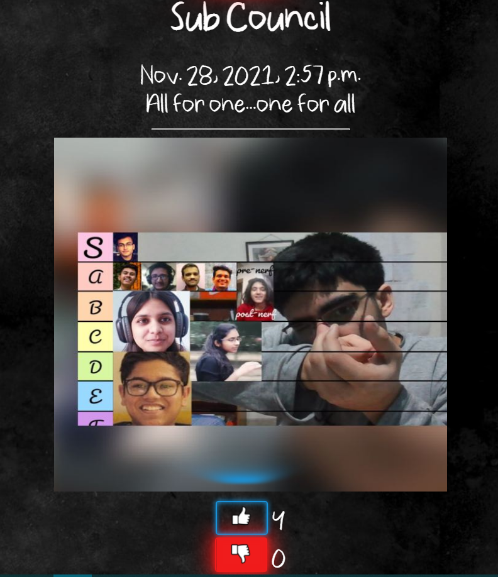Social Media view post

***in html***

{% for i in data %}

            {% for i in data %}

                <div *id*="content">

                    <div *id*="details_box">

                        <p><h2>{{i.user_id}}</h2>

                        {{i.post_date}}

                        <br>

                        {{i.post_text}}

                        <br>

                        <hr *width*=250 *px*>

                        {% if i.post_img %}

                            <img *src* = "media/{{i.post_img}}" *height*= 450px *width* = 500px>

                        {% else %}

                            <p></p>

                        {% endif %}

                        <form *action*="{% url 'likes' i.id%}" *method*="POST">

                        {% csrf_token %}

                            <button *type* ='submit' *class* = 'like-button'><img *src*="{% static 'images/like.png' %}" *height*= 30 *px*></button>  {{i.likes}}

                        </form>

                        <form *action* = "{% url 'dislikes' i.id%}" *id*="stud_deet" *method*="post">

                        {% csrf_token %}

                            <button *type* = 'submit' *class* = 'dislike-button'><img *src*="{% static 'images/dislike.png' %}" *height*= 30 *px*></button>  {{i.dislikes}}

                        </form

                        <*hr* *width*=400 *px*, *height* = 10px><hr *width*=400 *px*, *height* = 10px></p>

                    </div>

***In views.py***

def sm_post(*request*):

    if request.user.is_authenticated:

        print("user is authenticated")

        posts = post.objects.all()

        for i in posts:

            setattr(i, 'username', i.user_id.username)

        return render(request, 'sm_post.html', {'data':posts})

    else:

        print("else")

        return redirect('/')

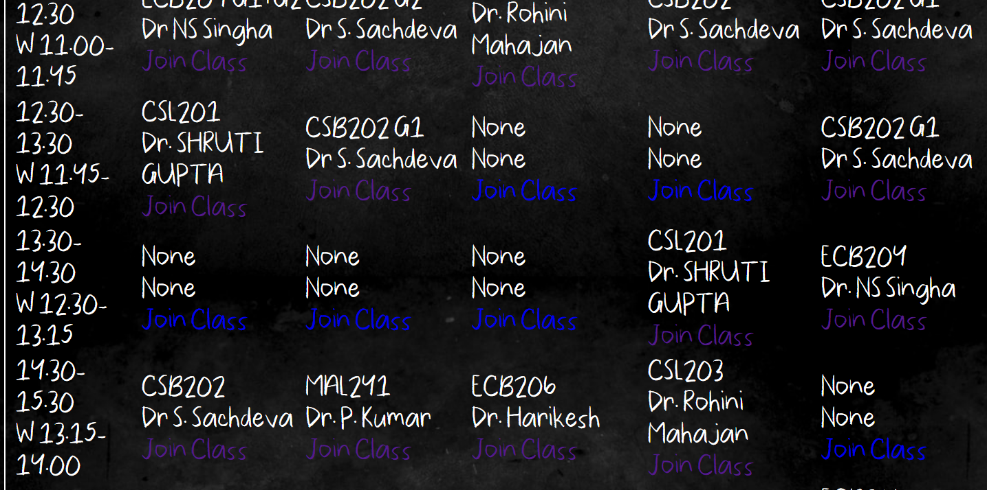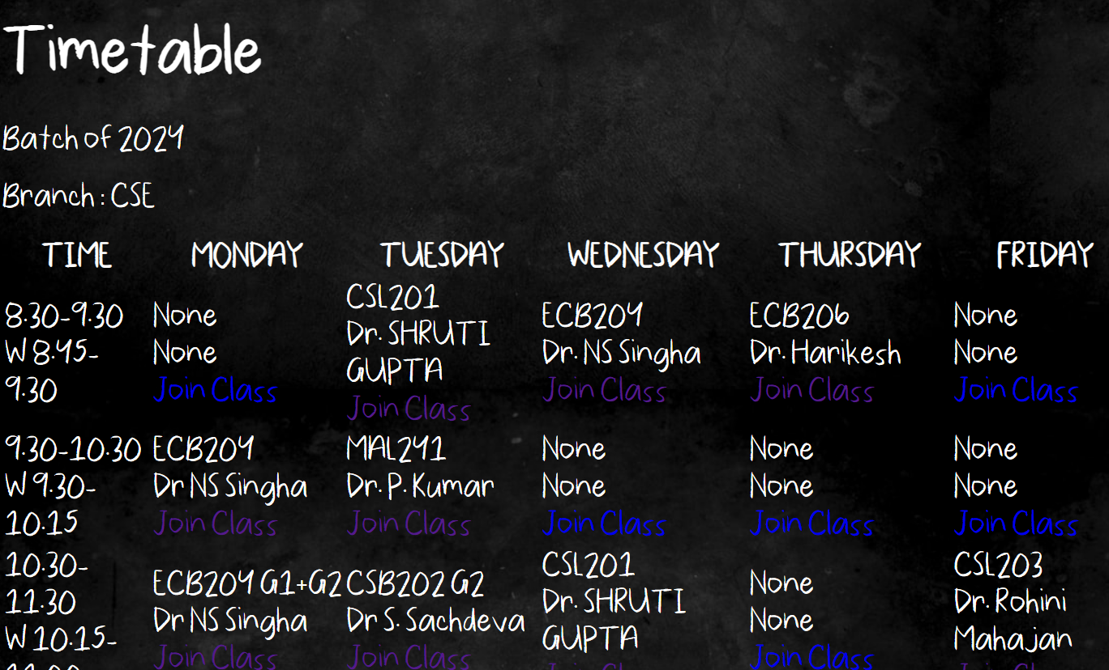TimeTable

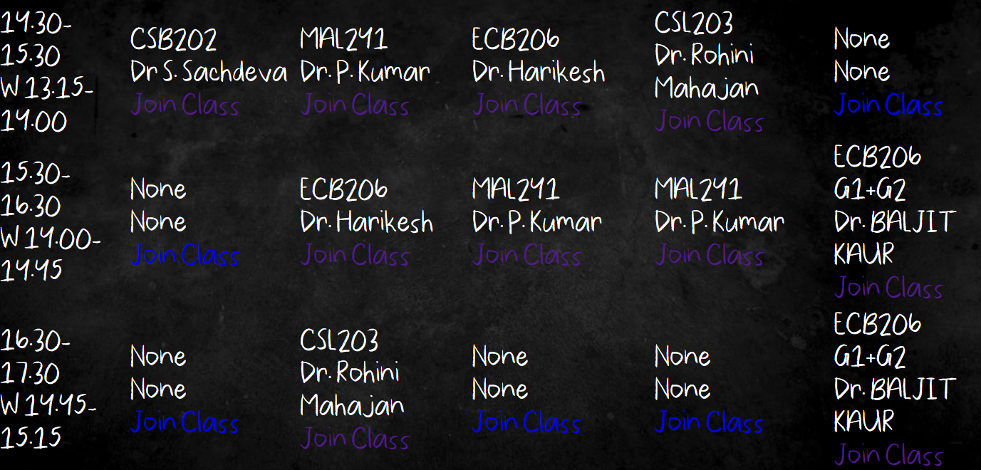

***In html***

<h1>Timetable</h1>

            <p> Batch of  {{user.year}}</p>

            <p> Branch : {{user.branch}}</p>

            <table *class*="table table-bordered">

                <thead>

                    <tr>

                        <th>TIME</th>

                        <th>MONDAY</th>

                        <th>TUESDAY</th>

                        <th>WEDNESDAY</th>

                        <th>THURSDAY</th>

                        <th>FRIDAY</th>

                    </tr>

                </thead>

                <tr>

                    <td>8.30-9.30<br>W 8.45-9.30</td>

                    {%for i in data_cse_1%}

                       <td> {{i.subject_id}}<br>

                        {{i.teacher_name}}<br>

                        <a *href*="{{i.gmeet_link}}">Join Class</a>

                        </td>

                    {%endfor%}

                    </tr>

                <tr>

                    <td>9.30-10.30<br>W 9.30-10.15</td>

                    {%for i in data_cse_2%}

                       <td> {{i.subject_id}}<br>

                        {{i.teacher_name}}<br>

                        <a *href*="{{i.gmeet_link}}">Join Class</a>

                        </td>

                    {%endfor%}

                </tr>

                <tr>

                    <td>10.30-11.30<br>W 10.15-11.00</td>

                    {%for i in data_cse_3%}

                       <td> {{i.subject_id}}<br>

                        {{i.teacher_name}}<br>

                        <a *href*="{{i.gmeet_link}}">Join Class</a>

                        </td>

                    {%endfor%}

                    <td></td>

                </tr>

                <tr>

                    <td>11.30-12.30<br>W 11.00-11.45</td>

                    {%for i in data_cse_4%}

                       <td> {{i.subject_id}}<br>

                        {{i.teacher_name}}<br>

                        <a *href*="{{i.gmeet_link}}">Join Class</a>

                        </td>

                    {%endfor%}

                    <td></td>

                </tr>

                <tr>

                    <td>12.30-13.30<br>W 11.45-12.30</td>

                    {%for i in data_cse_5%}

                       <td> {{i.subject_id}}<br>

                        {{i.teacher_name}}<br>

                        <a *href*="{{i.gmeet_link}}">Join Class</a>

                        </td>

                    {%endfor%}

                    <td></td>

                </tr>

                <tr>

                    <td>13.30-14.30<br>W 12.30-13.15</td>

                    {%for i in data_cse_6%}

                       <td> {{i.subject_id}}<br>

                        {{i.teacher_name}}<br>

                        <a *href*="{{i.gmeet_link}}">Join Class</a>

                        </td>

                    {%endfor%}

                    <td></td>

                </tr>

                <tr>

                    <td>14.30-15.30<br>W 13.15-14.00</td>

                    {%for i in data_cse_7%}

                       <td> {{i.subject_id}}<br>

                        {{i.teacher_name}}<br>

                        <a *href*="{{i.gmeet_link}}">Join Class</a>

                        </td>

                    {%endfor%}

                    <td></td>

                </tr>

                <tr>

                    <td>15.30-16.30<br>W 14.00-14.45</td>

                    {%for i in data_cse_8%}

                       <td> {{i.subject_id}}<br>

                        {{i.teacher_name}}<br>

                        <a *href*="{{i.gmeet_link}}">Join Class</a>

                        </td>

                    {%endfor%}

                    <td></td>

                </tr>

                <tr>

                    <td>16.30-17.30<br>W 14.45-15.15</td>

                    {%for i in data_cse_9%}

                       <td> {{i.subject_id}}<br>

                        {{i.teacher_name}}<br>

                        <a *href*="{{i.gmeet_link}}">Join Class</a>

                        </td>

                    {%endfor%}

                    <td></td>

                </tr>

                </table>

            </div>

            {% comment %} <form action="/todo" id="stud_deet" method="post">

            {% csrf_token %} {% endcomment %}

            <div *id*="side_bar">

                <p>TODO:<button *type*="submit"><a *href* = "/todo_fn" >Add new TODO</a></button></p>

                {%for j in todo_cse%}

                <p>Reminder Date: {{j.reminder_date}}<br>

                {{j.todo_text}}</p>

                {% endfor %}

            </div>

***In views.py***

def home(*request*):

    if request.user.is_authenticated:

        if request.user.year == 2024 and request.user.branch =='CSE': #for cse 2024

            timetable_cse_1 = lesson.objects.filter(*year*=2024, *branch* = 'CSE', *period_no_id*=1)

            timetable_cse_2 = lesson.objects.filter(*year*=2024, *branch* = 'CSE', *period_no_id*=2)

            timetable_cse_3 = lesson.objects.filter(*year*=2024, *branch* = 'CSE', *period_no_id*=3)

            timetable_cse_4 = lesson.objects.filter(*year*=2024, *branch* = 'CSE', *period_no_id*=4)

            timetable_cse_5 = lesson.objects.filter(*year*=2024, *branch* = 'CSE', *period_no_id*=5)

            timetable_cse_6 = lesson.objects.filter(*year*=2024, *branch* = 'CSE', *period_no_id*=6)

            timetable_cse_7 = lesson.objects.filter(*year*=2024, *branch* = 'CSE', *period_no_id*=7)

            timetable_cse_8 = lesson.objects.filter(*year*=2024, *branch* = 'CSE', *period_no_id*=8)

            timetable_cse_9 = lesson.objects.filter(*year*=2024, *branch* = 'CSE', *period_no_id*=9)

            #for todo:

            todo_cse = todo.objects.filter(*user_id* = request.user.id)

            return render(request, 'home.html', {'todo_cse': todo_cse, 'data_cse_1': timetable_cse_1, 'data_cse_2':timetable_cse_2, 'data_cse_3':timetable_cse_3, 'data_cse_4':timetable_cse_4, 'data_cse_5':timetable_cse_5, 'data_cse_6':timetable_cse_6, 'data_cse_7':timetable_cse_7, 'data_cse_8':timetable_cse_8, 'data_cse_9':timetable_cse_9})

        else:

            return render(request,'home.html')

    else:

        return redirect('/')

***in models.py***

class linklesson(*models*.*Model*):

    time_phase = models.CharField(*max_length*=20)

    period_no = models.IntegerField(*default*=1)

class lesson(*models*.*Model*):

    year=models.IntegerField(*max_length* =4, *default* = 2024, *null* = True)

    branch=models.CharField(*max_length*=3, *default* = 'CSE')

    period_day = models.CharField(*max_length*=10)

    subject_id = models.CharField(*max_length*=15, *null* = True)

    gmeet_link = models.CharField(*max_length*=1000, *null* = True)

    # period_no = models.IntegerField()

    period_no = models.ForeignKey(linklesson, *on_delete*=models.SET_NULL, *null*=True)

    teacher_name=models.CharField(*max_length* = 50, *null* = True)

|  |  |  |
| --- | --- | --- |
|  | BIBLIOGRAPHY |  |

<https://www.youtube.com/watch?v=OTmQOjsl0eg&t=5317s> <https://www.w3schools.com/js/js_ajax_intro.asp> <https://www.tutorialrepublic.com/html-tutorial/html-forms.php> <https://www.freecodecamp.org/news/how-to-center-anything-with-css-align-a-div-text-and-more/> <https://www.w3schools.com/howto/howto_js_slideshow.asp> <https://css-tricks.com/> <https://developer.mozilla.org/en-US/docs/Web> <https://www.geeksforgeeks.org/html-tables/>

<https://stackoverflow.com/questions/14675738/display-an-image-located-in-the-database-in-django/14675921>

<https://codedec.com/tutorials/upload-and-display-image-in-django/>

<https://www.youtube.com/watch?v=1UvTNMH7zDo&list=PLbcZOMGdqnietQ446-P300PiUHkvUF6bz&index=3&t=2727s>

<https://www.youtube.com/watch?v=HshbjK1vDtY&list=PLbcZOMGdqnietQ446-P300PiUHkvUF6bz&index=4&t=2655s>

https://www.youtube.com/watch?v=6xNcXwC6ikQ&list=PLbcZOMGdqnic75EfefBte7yyIGl3rnMD-&index=3&t=590s

1. https://www.javascript.com/
2. https://www.mysql.com/
3. https://www.djangoproject.com/